Mindfulness & Conscious Living

Group Mentoring Program
with
Dr. Bill Cook & Wendy Carty
Thursdays April 9th to June 4th, 2026
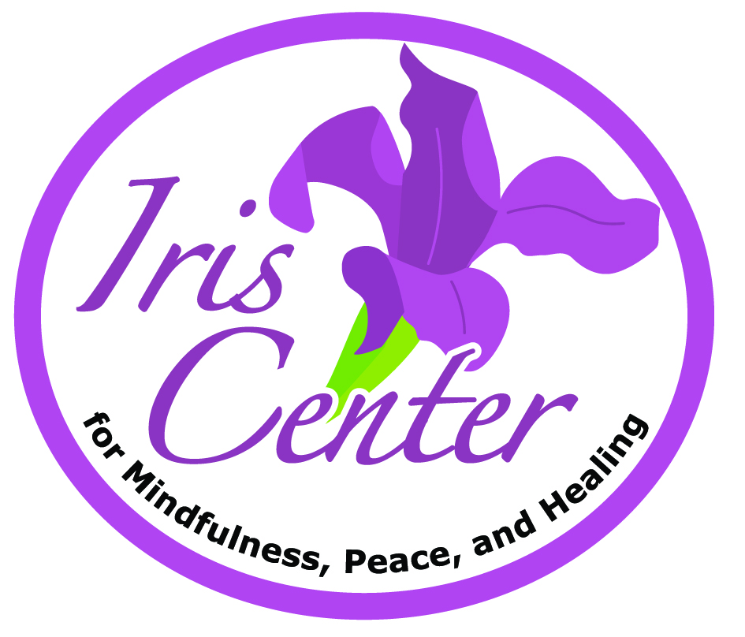
Time 6:30 to 9:00 p.m.
The Iris Center
160 Sunset Drive
Fredericton, NB E3A 1A3
Based in thousands of years of experiential evidence, decades of recent research on mindfulness and the recently published research on our program, we are pleased to offer Mindfulness and Conscious Living this spring. Register now.
Details and Registration on the back, please submit by March 31, 2026

Contact bill@iriscenter.ca Call: 506-457-4747

Mindfulness & Conscious Living
A group mentoring program for anyone interested in exploring ‘mindfulness’ and how it can help to “meet, greet, face and embrace” Life as it arises. The program consists of 30 hours of guided practice, pointers and conversation through 9 weekly sessions (2.5-3.0 hours), and an All Day Retreat (7 hours) at the end of the 5th week. Although mindfulness is a skill/capacity we all share, it is a skill that can be strengthened through training, so each session builds on the learnings from the previous sessions and a commitment to attendance is critical.
April 9 Session 1 Education/Orientation
April 16 Session 2 Ways of Seeing
April 23 Session 3 The Storyteller
April 30 Session 4 Beyond Story
May 7 Session 5 ‘Koyaanisqatsi’ - How we suffer – Pain
May 14 Session 6 ‘Koyaanisqatsi’ - How we suffer – Moods & Emotions
All Day Session (Saturday or Sunday May 16 and 17)
May 21 Session 7 ‘Koyaanisqatsi’ - How we suffer – Worry & Anxiety
May 28 Session 8 ‘Koyaanisqatsi’ - How we suffer - Habits & Addictions
June 4 Session 9 The Practice Is Living

Cost: $450.00 Please pay with registration. Deadline for registration is March 31st.
Register by returning this form with payment by March 31st 2026.
E-transfer to bill@iriscenter.ca or by cheque to Dr. William A. Cook
Name: Click or tap here to enter text. DOB: Click or tap here to enter text.
Address: Click or tap here to enter text.
Email: Click or tap here to enter text. Phone: Click or tap here to enter text.

Briefly, what are you looking for in taking the program?
Click or tap here to enter text.

Do you experience any medical issues/concerns it would be helpful for us to know about? Yes / No
If Yes, please provide a little detail … Click or tap here to enter text.

